# Emerging Innovators Fellowship

# Submission Pack

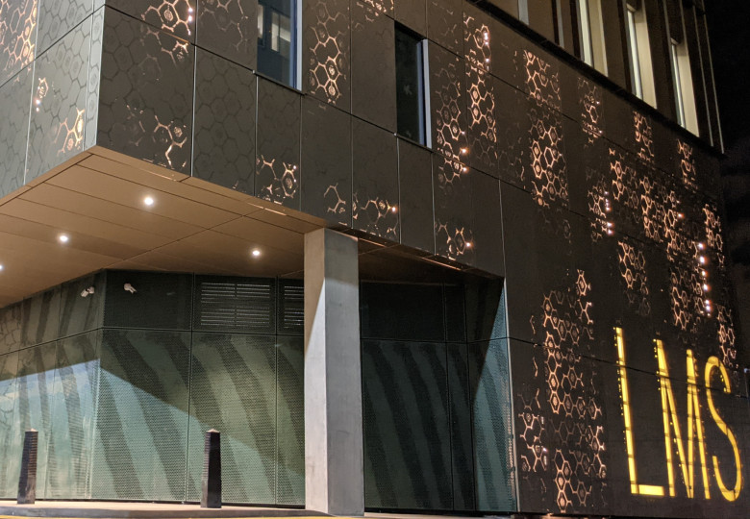

# How to use this submission pack

Please read this submission pack carefully before applying for the Emerging Innovators Fellowship on the recruitment platform.

You will be required to submit 3 documents on the online application portal, details of which can be found in this pack:

1. Screening Document
2. Scientific CV
3. Scientific Cover Letter

**Applications made without these documents attached will not be considered.**

[**Please click here to read the Privacy Notice which will let you know what MRC Laboratory of Medical Sciences (MRC LMS) does with your personal data.**](https://lms.mrc.ac.uk/wp-content/uploads/Privacy-Notice-Emerging-Innovators-Fellowship.pdf)

# Screening Document

**Equal Opportunities Monitoring**

**This part of the form is strictly confidential and used purely for monitoring purposes to help us ensure that our equal opportunities policies are working. The monitoring categories reflect those used by the Higher Education Statistics Agency in accordance with the provisions of the Equality Act 2010.**

Please complete the following form and submit this in the document upload section of the recruitment portal with your Scientific CV and Scientific Cover Letter.

1. I am a:

UK domiciled researcher wishing to conduct my research in the UK

**Or**

Non-UK domiciled researcher who has studied in the UK for my undergraduate degree and/or PhD

1. I have completed a PhD before March 2025 and have proof of certificate
2. I am from a Black/Black Heritage Background
3. I have provided the MRC LMS with two references and I am happy for them to be contacted prior to an offer of interview

Print Name:

Date:

# Scientific CV

This section details guidance that may be helpful to consider when writing your Scientific CV. You are not required to use the below format. Please submit your Scientific CV in the document upload section of the recruitment portal with your Screening Document and Scientific Cover Letter.

**Personal Information**

* Address and contact information, including your work address if relevant

**Education**

* Details of where you have studied, and from when. Start with your most recent educational achievement, and work backwards chronologically.

**Employment History**

* Details of where you have worked and your role there. Start with your most recent workplace, and work backwards chronologically.

**Awards**

* Include details of any scholarships or awards you have achieved throughout your study and professional life

**Publications**

* Include details of your publications listed in citation format.

**Skills**

* Mention key areas of expertise, particularly those relevant to the Research Group you are applying to join and your own research.

**Teaching and mentoring**

* Details of any teaching you may have done, including modules
* Details of any scientific mentoring you may have done, e.g., of Masters or PhD students

# Scientific Cover Letter Questions

This section details the questions you **must** answer in your Scientific Cover Letter. The following page contains additional information around each of the application questions, including examples of how you could respond to each prompt. Please submit your Scientific Cover Letter in the document upload section of the recruitment portal with your Screening Document and Scientific CV.

1. Which research group would you like to work in at the LMS? Which Group Heads at the LMS have you reached out to? What was the outcome of these conversations? **(150 words)**
2. Why would you like to work in this research group? How does it fit into the context of your scientific journey, and what do you hope to learn there? **(450 words)**
3. What important question(s) do you want to address in your work during your time at the LMS? **(300 words)**
4. What is your career ambition? **(100 words)**
5. Tell us about your research so far. What skills and experiences can you bring to the group? **(800 words)**  
   This could include:  
   - Papers published  
   - Presentations at conferences  
   - How you have worked as part of a team to achieve scientific outcomes  
   - Any experience working in collaboration with other institutes/with industry
6. Please tell us about any career breaks, secondments, volunteering, part-time work, other relevant experience (including any time spent in different sectors), that might have affected your progression as a scientific researcher. Sharing this information with us will not negatively impact your application. **(200 words)**

# Guidance Notes for the Scientific Cover Letter

The following pages detail examples of how you could respond to each question that makes up the Scientific Cover Letter

## Which research group would you like to work in at the LMS? Which Group Heads at the LMS have you reached out to? What was the outcome of these conversations? (150 words)

Please refer to one or two research groups you are interested in working within at the LMS. This group should be your best scientific fit. As there is some overlap between some of our research groups, you may want to reach out to one or two group leaders before confirming your choice.  
  
This question also enables you to demonstrate that you have taken a proactive approach to your application and understand the different research groups at the LMS. This shows that you are capable of the independent enquiry essential in the transition to postdoctorate level research.  
  
To organise an introduction with an LMS group head, please contact us at (lmspeopleandculture@imperial.ac.uk). Due to the nature of life as a scientific researcher, you may not receive an immediate response. Please do not panic if you have not received a response by the application closing date. You will not be penalised for this.

1. Why would you like to work in this research group? How does it fit into the context of your scientific journey, and what do you hope to learn there? (450 words)

This is your opportunity to share how your research experience and contributions to the research environment will enrich your fellowship experience at the LMS and within your chosen group. Are there any specific publications you have worked on, or research outputs you have been involved with that are linked to the work conducted by the LMS research group? Are there any papers or outputs the group may have published recently that may be of interest to you, or any methodologies and analyses used by the group that would support you on your own journey as a researcher?

1. What important question(s) do you want to address in your work during your time at the LMS? (300 words)

We are not asking for a fully developed research proposal at this stage, but would like you to demonstrate that you have identified an area of focus for your research that fits in with the science conducted by your chosen research group. This could include some key questions you would like to answer, any hypotheses you would like to test, and methodologies you would use to conduct your research.

1. What is your career ambition? (100 words)

Tell us about where you would like your career in scientific research to take you, and how working at the LMS will facilitate this. For example, do you have ambitions of leading your own research group, or continuing your career in academia? Or are you interested in pursuing a career in industry, or becoming a science advisor?

## Tell us about your research so far. What skills and experiences can you bring to the group? (800 words) This could include: - Papers published - Presentations at conferences - How you have worked as part of a team to achieve scientific outcomes - Any experience working in collaboration with other institutes/with industry

This question is your opportunity to tell us in more detail about your research career so far. We understand that scientific outputs may look different depending on your career journey. The list below is non-exhaustive and encompasses prompts that may be helpful to consider when preparing your answer to this question. You do not have to include an example of each element, and your response should include a balance of both research outputs and additional contributions to the development of others/development of a positive research culture.

* Publications, including your specific contributions. You could discuss why you have selected these publications in particular, e.g., relevance, scale of work, personal accomplishment as part of the wider project
* Other research outputs that are of relevance to your application and indicative of your approach to conducting research. This could include datasets, educational materials, products you have created/been involved with creating as part of a team for other environments (e.g., industry, healthcare), key skills you have used to develop ideas and test hypotheses
* Whether you have mentored or helped others develop in the course of your research career, e.g., supporting PhD or Masters students, working with interns, working with schools
* How you have helped individuals within a team to achieve collective success, e.g., collaborative contributions to wider project goals, or evaluating researchers/research projects to support project aims, or editing and reviewing group work
* Details of any funding or awards you have received for your work
* Your approach to research communication, both written and verbal, experiences communicating your ideas and results to different audiences (e.g., scientific and non-scientific)
* Your contributions to research culture. This could include committee/network membership or leadership, organization of events to the benefit of your research community, contribution to any events promoting equality, diversity, and inclusion in research and research culture
* Social engagement, either with industry, private or public sectors, and the wider public. This could include how you have engaged key stakeholders (patients, charities) in clinical trials and processes undertaken as part of your research, how you have gathered patient and stakeholder feedback and included this in future research processes.

1. Please tell us about any career breaks, secondments, volunteering, part-time work, other relevant experience (including any time spent in different sectors), that might have affected your progression as a scientific researcher. Sharing this information with us will not negatively impact your application. (200 words)

We understand that no research career path is the same, and that there are many and multiple reasons why an individual may have taken a non-linear route. This question helps us to contextualise your journey as a researcher, and furthermore provides an opportunity to draw out transferrable experience in other sectors.